Multi-Grid Implementation

The MOONS Multi-Grid (MG) method is a node-based geometric MG solver to solve the equation

$$∇^{2}u=f$$

# Number of levels

In MOONS, the number of levels is a fixed and prescribed value. The shape of the jth level is

$$s_{j}=ceiling\left(\frac{s_{0}}{2^{j-1}}\right)$$

Where

$$s_{0}=shape(u)$$

# Restriction

When the number of nodes in a given direction is odd, restriction is straight forward. But when the number of nodes in a given direction is even, interpolation to an odd grid is necessary first to ensure symmetry of the function and BCs. To be clear

## Restriction of odd number of nodes

Here, restriction is straight forward. If $s_{j}≥1$ and if the shape of $s_{j}$ is odd there will be a remainder. But since the ceiling is taken from section 1, it can be seen that the $j+1$ level has shape (along a given direction)

$$s_{j+1}=\frac{s_{j}+1}{2}$$

This means that the number of nodes that are removed are

$$nodes\left(removed\right)=2,4,…,s_{j}-1$$

Note that the 2nd and $s_{j}-1$ nodes are removed, therefore the reduction of nodes is symmetric.

## Restriction of even number of nodes

Here, restriction requires some extra work. If the shape of $s_{j}$ is even there will NOT be a remainder.

$$s_{j+1}=\frac{s_{j}}{2}$$

But the number of removed nodes must be symmetric, therefore interpolation is necessary first, which reduces the shape by 1, let's denote this new shape by $s_{j}^{*}=s_{j}-1$. The nodes removed will then be

$$nodes\left(removed\right)=2^{*},4^{*},…,s_{j}^{*}-1$$

The stars indicate that these nodes are the result of interpolation to a grid of size $s_{j}-1$ first.

# Prolongate (interpolation)

In order to prolongate, a routine was developed to linearly interpolate along one direction at a time:

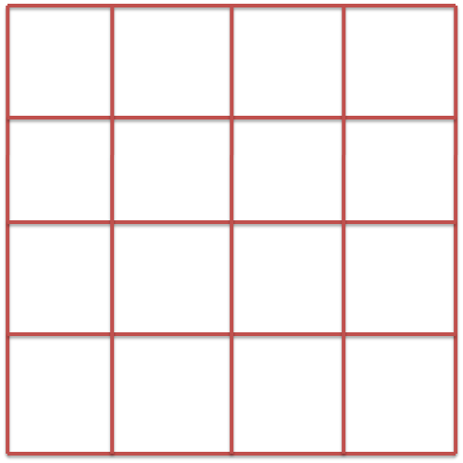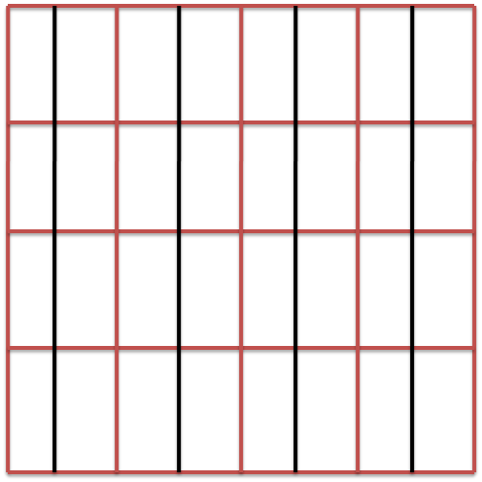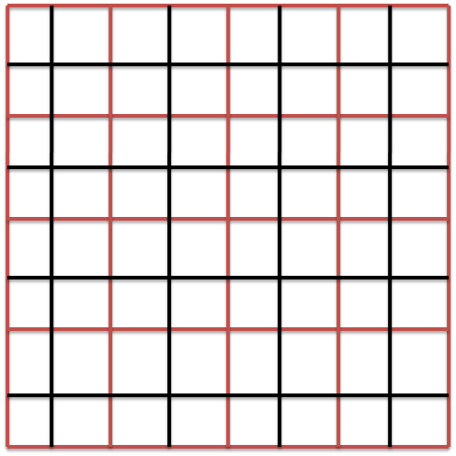

# Restriction

## Odd number of nodes

In order to restrict, a routine was developed to linearly interpolate and then average local function values along one direction at a time:

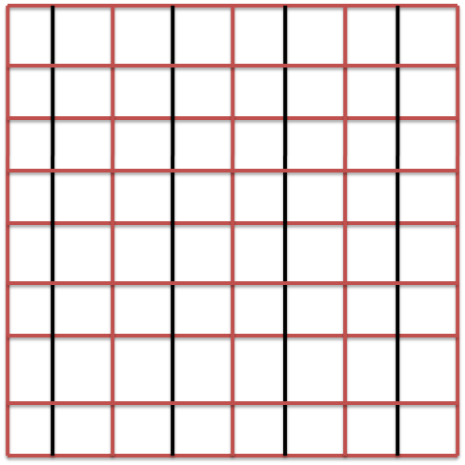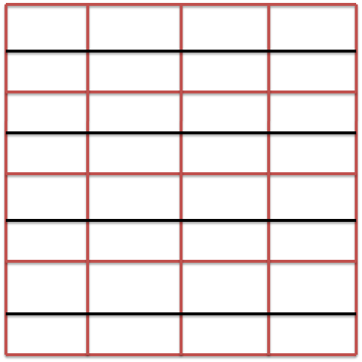

## Even number of nodes

In order to restrict, a routine was developed to linearly interpolate and then average local function values along one direction at a time:



Linearly interpolating we have

$$\frac{f_{i}-f_{i+1}}{h_{i}-h_{i+1}}=\frac{f_{i-1}-f_{i+1}}{h_{i-1}-h_{i+1}}$$

Solving for the interpolated value yields

$$f_{i}=f_{i+1}+α(f_{i-1}-f_{i+1})$$

Where

$$α=\frac{h_{i}-h_{i+1}}{h_{i-1}-h_{i+1}}$$

So the value of the restricted field is

$$r_{i}=\frac{1}{2}\left(f_{i}+f_{i+1}+α\left(f_{i-1}-f_{i+1}\right)\right)$$

# V-Cycle (one level deep)

1) Smooth solution

2) Calc residual

3) Restrict residual

4) The error needed to correct the solution satisfies Laplace's equation where the source term is the residual!

5) Solve for error with initial guess of zero:

6) Prolongate coarse correction

7) Correct solution

8) Final smoothing

$$u=SOR(u,f)$$